Dose Rate Calculations for Use of a Varian 1800 in Tests at Technical Options Site in Newark

By Martin E. Nelson, US Naval Academy, Annapolis, MD.

Tests are to be conducted to determine the beam profile using a rebuilt Varian1800. A schematic of the equipment including the system’s gantry, stand, and baseframe along with the room dimensions in which the tests are to be conducted is shown on the attached document.

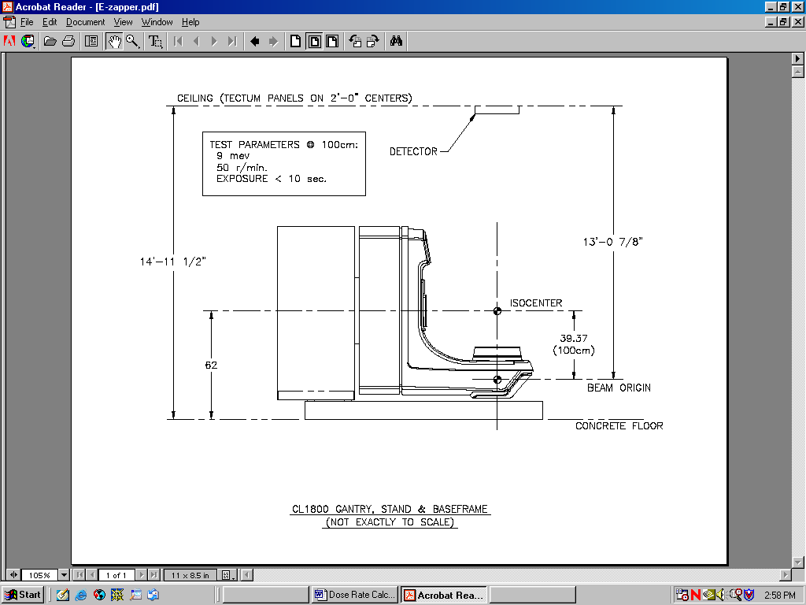

For these tests, the system will be operated in electron mode with the beam’s isocenter at 100 cm or 1 meter from the beam origin. The following test conditions will be employed:

- Beam at isocenter with a dose rate of 50 rads/minute;
- An exposure time not to exceed 10 seconds;
- Electron’s beam energy is 9 MeV.

The purpose of the these tests is to measure the spread of the beam using a Faraday cup, which will be located vertically near the ceiling of the building and then moved horizontally to measure the dispersion of the beam. Based on the dimensions given in the schematic, the beam origin has been determined to be 3.98 meters (13’-7/8”) from the ceiling, while the beam’s isocenter is 1 meter from the beam’s origin. The ceiling is composed of Tectum panels, which are 1” thick and lies on 2’ center trusses. There is 6” of fiberglass in the attic. The roof is 6” of OSB with asphalt shingles.

The purpose of this document is to provide dose rate calculations in order to define test conditions such that a dose rate of 2 mrem/hr will not be exceeded in the adjacent test areas. To perform these calculations the following assumptions were made:

1, electron beam conical angular spread from the isocenter is 15 (7.5 half-angle spread);
- ceiling is treated as wood (a low Z material) and is assumed to have a density of 0.9 grams/cm³;
- there is no self-absorption of the x-rays generated within the ceiling by the incident electrons;
- x-ray emission rate from the ceiling and the ensuing dose rate is based on normal electron incidence using the procedures and data outlined in NCRP report #51;
- dark current emitted directly behind the accelerator has a magnitude of 350 mrem/hr² and occurs continuously even when accelerating voltage is not applied to the tube;
- quality factor (Q) is unity for both electrons and x-rays;
- energy loss of the electrons through the air is negligible (an assumption recommended by NCRP report #51).

Electron Projected Range and Range in air and wood

The projected range of electrons in a medium can be found by the equation:

R_{pr} = 0.53 E - .106 (1)

Where:
R_{pr} = projected electron range, g/cm²

E = electron energy, MeV

The range of the electron can then be found by the equation:

R = R_{pr} /  (2)

Where:

 = density of the medium, grams/cm³

Using equations (1) and (2), the following table has been constructed for 9 MeV electrons:

Medium | Medium density | R_{pr} | Range (R) | Range (R)
units | Grams/cm³ | Grams/cm² | cm
Air | 0.0012 | 4.66 | 3,883 | 38.83 meters
Wood | 0.9 | 4.66 | 5.17 | 2.04 inches

Since the ceiling has only 1” of Tectum, the electrons would not be entirely stopped in this thickness. However, for the purposes of these calculations the electrons are assumed to be stopped by the combination of materials in the ceiling and the roof. This is a reasonable assumption given that the roof consists of fiberglass, OSB, and asphalt shingles besides the Tectum. Alternatively, an additional 1” panel of Tectum could be placed in ceiling. Calculations have shown that at the ceiling the beam would have radius of 0.39 meters or 15.35”. Thus a rectangular area of 31”centered directly over the beam’s isocenter would be needed to ensure no electrons reach the fiberglass or the other materials in the roof.

Calculation of Beam Current at Isocenter (1 meter from beam origin)

NCRP report 51 provides the following relationship for the dose rate from an electron beam stopped in a low Z material:
.
D = [E * I / R_{pr} ] * 10⁸ (3)

Where: .
D = absorbed dose index rate in the medium, rads/sec

E = electron energy, MeV

I = electron current density, mA/cm²

R_{pr} = projected electron range in the medium, g/cm²

At the isocenter, which is 1 meter from the system’s output port, the dose rate will be 50 rads/min or 0.83 rads/sec. Rearranging equation (3) and solving for the electron current density at the isocenter (I_{iso}) gives the result:

.
I_{iso} = [D R_{pr} /E] x 10⁻⁸ = [(.83 rad/sec)(4.66 g/cm²)/9 MeV] * 10⁻⁸= 4.3 *10⁻⁹ mA/cm² (4)

Electron Beam Current at Ceiling (3.98 meter from beam origin)

Assuming the beam intensity decreases inversely proportional to the square of the distance traveled by the electrons from the beam origin, the electron beam intensity at the ceiling (I_{ceil}) will be as follows:

I_{ceil} =I_{iso} [ r_{iso} / r_{ceil} ]² =(4.3*10⁻⁹ mA/cm²)(10⁴ cm²/m²)[1 m/3.98 m]² = 2.7*10⁻⁶ mA/m² (5)

Where:

r_{iso} = distance isocenter from beam origin, 1 meter

r_{ceil} = distance ceiling from beam origin, 3.98 meters
.
X-ray Absorbed Dose Rate in Ceiling

The electrons impinging on the ceiling will generate x-rays. The maximum dose rate from these x-rays at a distance of 1 meter from the ceiling can be found from the relationship:
.
D_{ceil} = I_{ceil} * 5 x 10⁴ * C (Z, ) (6)

Where:
.
D_{ceil} = x-ray absorbed dose rate, rads/min

I_{ceil} = electron beam intensity incident on ceiling, mA/m²

5 x 10⁴ = factor from NCRP report #51 (see footnote 6), rads m²/mA-min

C(Z, ) = correction factor, which corrects dose rate for both low Z target compared to high Z target and x- ray emission angle

At a 0 degree emission angle, the x-rays would be headed vertically upward. The absorbed dose rate would then be as follows:
.
D_{ceil} = 2.7*10⁻⁶ mA/m² * 5 x 10⁴ rads m²/mA-min *0.5 = .0675 rads/min (7)
.
This absorbed dose rate would correspond to a dose equivalent rate in the ceiling (H _{ceil}) in units of mrem/hr :
. .
H_{ceil}=D_{ceil}Q=(.0675 rads/min)(1 rem/rad)(60 min/hr)(10³ mrem/rem)= 4050 mrem/hr (8)

This would be the dose rate for continuous operation at distance of 1 meter above the ceiling in the vertical direction or 0 angle (H_{ceil} (1 meter, 0)) with the beam. However, assuming the tests are conducted for 10 seconds and 1 test is conducted per hour, then the dose equivalent rate at this point would be equal to:
.
H_{ceil}(1 meter,0)=(4050 mrem/hr)(10 sec/test)(1 test/hr)(1 hr/3600 sec=11.2 mrem/hr (9)

The dose equivalent rate in the ceiling at a distance of 1 meter and an angle of 90 (H_{ceil} (1 meter, 90)) to the beam under the same conditions would be 60% of amount given in equation (9) , because the C(, Z) is reduced to 0.3 from 0.5 when x-rays move in this 90 direction. Hence,
.
H_{ceil} (1 meter, 90) = 11.2 mrem/hr * 0.6 = 6.7 mrem/hr (10)

The standard to conduct the tests will be that the dose rate to all personnel must be less than 2 mrem/hr. The dose equivalent rate will decrease inversely proportional to the square of the distance (r) that an individual is away from H_{ceil}(1 meter,0) and can be given by the equation:
. .
H = H_{ceil}(1 meter,0) (1/ r )² (11)

Where:
. .
H = dose equivalent rate to an individual at distance r meters away from H_{ceil}(1 meter,0), mrem/hr
.
- = distance above ceiling where H_{ceil}(1 meter,0) determined, 1 meter
.
r = distance facility personnel from H_{ceil}(1 meter,0), meters
.
Setting H equal to 2 mrem/hr and using the dose equivalent rate from equation (9) gives the result that an individual must be 2.4 meters away from this point. This in fact will always occur due to the fact that the height of the ceiling above the isocenter is 2.98 meters.

Dark Current Dose Equivalent Rate Due to X-rays Reflecting off Concrete Floor

As mentioned in assumption #5 on page 1, the dark current from the system has been determined to be 350 mrem/hr. These x-rays could scatter off the concrete floor and make a contribution to an individual’s dose. This dose rate can be found from the equation:
. .
H_{dc,refl} = H_{dc}  (12)

Where:
.
H_{dc,refl} = dose equivalent rate from dark current reflected off concrete floor below beam origin, mrem/hr
.
H_{dc} = dark current dose equivalent rate from system (see footnote 2), 350 mrem/hr

- = Albedo for 9 MeV x-rays scattering off concrete, .003

Thus the dose equivalent rate for this term has been determined to be as follows:
.
H_{dc,refl} = 350 mrem/hr *.003 = 1.0 mrem/hr (13)

The dose equivalent rate on the floor from x-ray generation in the ceiling would be less than 1 mrem/hr based on combining equation (11) with the floor to ceiling height of 3.98 meters, and the x-ray generation rate in the 90 direction. Consequently, the combined dose equivalent rate of dark current floor reflection and x-ray generation in the ceiling will be always less than 2 mrem/hr within the facility.

Based on email communications between Steve Andrews and Martin Nelson, February 18-22, 2005.
Based on information given during at Technical Options with Steve Andrews, James Ziegler, Martin Nelson, December 21, 2004.
NCRP report #51, “Radiation Protection Design Guidelines for 0.1 MeV-100 MeV Particle Accelerator facilities”, March 1, 1977.
NCRP report #51, Appendix B.2
NCRP report #51, Appendix B.2
NCRP report #51, Appendix E.1, 5 * 10⁴ factor extrapolated from graph for 9 MeV incident electrons. Graph based on electrons incident on high Z- targets.
NCRP report #51, Appendix E.3, C(Z, ) recommended to be taken as 0.5 when x-rays emitted at 0 and to be taken as 0.3 when x-rays emitted at 90 from low Z target.
NCRP report #51, Appendix E.15
NCRP report #51, Appendix E.2 shows that the angular distribution of x-rays is relatively constant in high Z targets above 90. An angle of 180 would actually be required to reach the point where the dark current scatters off the concrete floor.

