24FEB06
MEMORANDUM

From: Midn 1/C Gonzales
Midn 1/C Reichl
To: Prof Nelson

Encl: (1) System Diagram
(2) LDS Vacuum Products, Inc Contact Information
(3) 2.75” Conflat Flange Nippple
(4) 2.75” Conflat Flangeed 6-way cross
(5) 2.75” Conflant to ISO63 Flange
(6) 2.75” Conflat Balnks

Subject: Conflat Flanges and Attachments needed for E-Zapper

1. The overall system will include 3 “nipples” that can be commercially ordered. A diagram of the overall system and the placement of the components can be seen in Encl(1). All of the parts can be ordered from LDS Vacuum Products, Inc. The contact information, including address and phone number can be found in Encl(2). Part descriptions, ordering numbers and the enclosure number of the part can be seen in Table 1.

Table 1
Part No. | Description | Quantity | Unit Cost | Total Cost | Encl
275-150-N | 2.75 “ Conflat Flange Nipple | 1 | $55.00 | $55.00 | 3
275-150-6X | 2.75”‘ Conflat Flanged 6 way cross | 1 | $265.00 | $265.00 | 4
275xISO63-CR | 2.75 “ Conflat to ISO 63 Flange | 1 | $120.00 | $120.00 | 5
275-000 | 2.75 Conflat Blanks (Non-Rotatable) | 4 | $12.00 | $48.00 | 6
275-000R | 2.75” Conflat Blanks (Rotatable) | 4 | $14.00 | $56.00 | 6
275-CG | Copper Gasket (10) | 2 | $14.00 | $25.00
 |  |  | Total | $572.00

2. According to the companies website they ship using FedEx Ground and shipping is free if order is placed over the internet. done over the internet.

Very Respectfully,

C.N. Gonzales M.A. Reichl
MIDN USN MIDN USN

4

1
2
4
3

1 - 2.75” Conflat Nipple- used to connect VAT fast acting valve to LINAC.
2 - 2.75” Conflat Flanged 6-way cross- used to integrate roughing pump, high vacuum pump, and fast acting valve sensors into system
3 - 2.75” Conflat to ISO63 flange- used to transition form Conflat sealing to the use of O-rings
4- 2.75” Conflat Blanks will be used to connect pumps and sensors to 6-way cross (appropriate openings will be made in blanks_

Encl (1)



Encl (2)

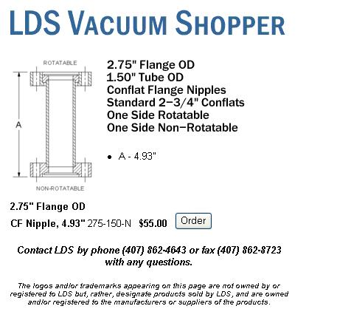

Encl (3)

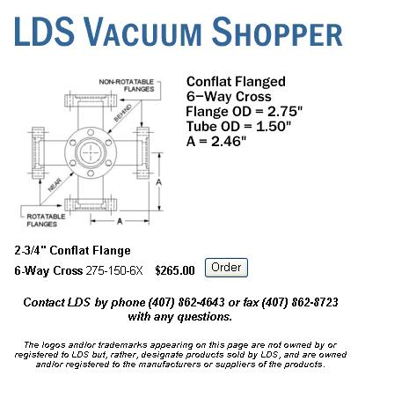

Encl (4)

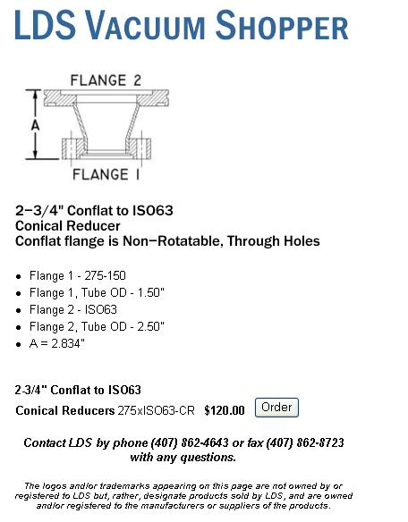

Encl (5)
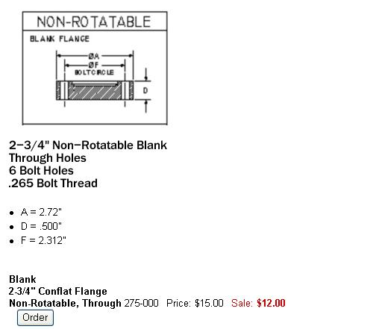

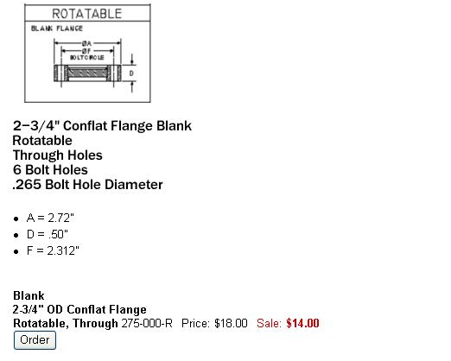
Encl (6)

